6DoF Flight Altitude Tracker Playbook
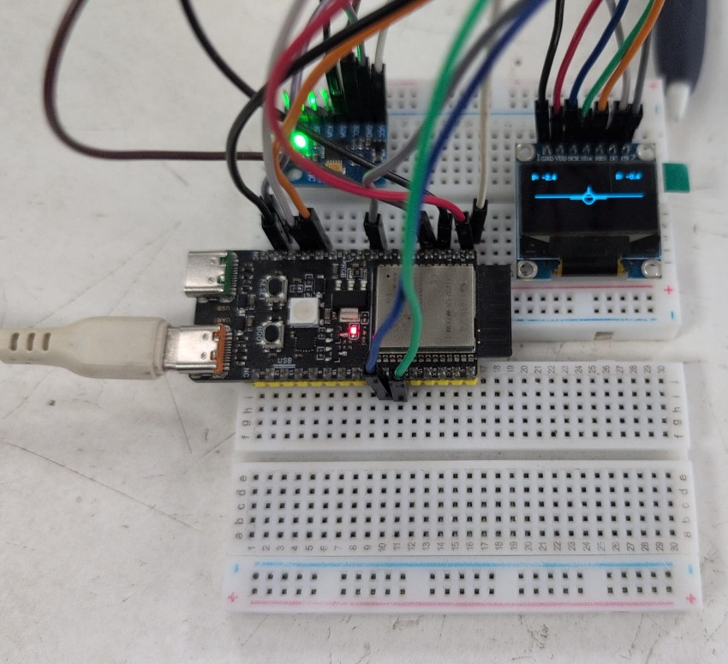
I. Challenge
Develop a real-time digital avionics instrument deck that measures dynamic physical orientation using a 6-Degrees-of-Freedom (6-DoF) Inertial Measurement Unit (IMU) and projects a responsive, fluid artificial horizon onto a dedicated graphical interface. The system must process dual high-speed hardware communication buses simultaneously while balancing sensor noise against calculation lag to provide lag-free flight telemetry.
II. Guide
A. Concept
To implement a high-refresh avionics dashboard, we leverage these fundamental embedded and mathematical principles:
- The 6-DoF Inertial Measurement Unit: A sensor housing a 3-axis accelerometer (measuring linear acceleration due to gravity) and a 3-axis gyroscope (measuring angular rotational velocity). Combining these six vectors tracks orientation across pitch, roll, and yaw.
  - Learn more: DigiKey DIY Avionics Simulator Guide
- Sensor Fusion & The Complementary Filter: Accelerometers offer stable data long-term but suffer from high-frequency structural vibration noise. Gyroscopes track rapid movements perfectly but gather minor mathematical errors over time, causing "integration drift". A complementary filter resolves this by applying a weighted blending ratio to balance both data streams:
$$θ_{\text{filtered}}=α⋅\left(θ_{\text{prev}}+ω⋅dt\right)+\left(1-α\right)⋅θ_{\text{accel}}$$
  - Learn more: Understanding Sensor Fusion
  - Learn more: The Complementary Filter
- 2D Rotational Screen Projection: Translating raw physical angles onto a flat, 2D display grid requires trigonometry. Changes in pitch shift the display center point up and down ($Y_{\text{offset}}$), while changes in roll rotate the horizon line's outer coordinates around that shifting pivot using sine and cosine functions.
  - Learn more: Working with OLED Displays
- Dual-Bus Hardware Pipeline: The microcontroller coordinates data over two separate communication interfaces concurrently: an $I^{2}C$ bus configured in Fast Mode ($400\text{ kHz}$) to pull raw spatial arrays from the IMU, and an SPI bus ($10\text{ MHz}$) to push display updates.
  - Learn more: Communication Protocols
- Full-Frame Memory Buffering: Modifying individual pixels directly on a physical display causes screen tearing and visual jitter. Instead, the display driver sets aside a local $1024$-byte array in the microcontroller's RAM to handle the calculation math secretly, flashing the completed image to the screen all at once via a single command transmission.
  - Learn more: U8g2 Graphic Engine Memory Modes
Real-World Example: Glass cockpit Primary Flight Displays (PFD) inside modern commercial airliners (like the Boeing 787 or Airbus A350) and glass instrument panels in general aviation aircraft (like the Garmin G1000). They ingest data from highly sensitive solid-state micro-machined sensors and instantaneously project pitch and bank horizons to pilots.
B. Components
- Microcontroller: WeAct Studio ESP32-C6 ($32$-bit RISC-V SoC with an internal hardware Floating Point Unit).
- Display: $0.96$-inch Simplex SPI monochrome OLED display module ($128×64$ resolution, SSD1306 driver).
- Spatial Sensor: MPU6050 6-DoF Integrated Circuit Module.
- Prototyping Tools: Solid hookup wires and a standard breadboard.
C. Connections
To keep the microcontroller stable during boot-up, communication lines are routed to clean general-purpose I/O pins, leaving system strapping pins completely untouched:
Peripheral Module | Physical Pin | Target Pin Designation | Signal Role | Electrical Conditions
SPI OLED | GND | GND | Ground Reference | $0\text{V}$ Ground Plane
 | VDD | 3V3 | Logic Power | $3.3\text{V}$ Low-Noise Power Rail
 | SCK | GPIO 21 | FSPICLK | Master Clock Output ($10\text{ MHz}$)
 | SDA | GPIO 22 | FSPID / MOSI | Master-Out Slave-In Data Interface
 | RES | GPIO 2 | GPIO Out | Active-Low Chip Reset Pin
 | DC | GPIO 3 | GPIO Out | Mode Switch ($0=\text{Command},1=\text{Data}$)
 | CS | GPIO 1 | FSPICS0 | Active-Low Peripheral Selection
I2C IMU | VCC | 3V3 | Logic Power | Shared $3.3\text{V}$ Power Rail
 | GND | GND | Ground Reference | Shared Ground Plane
 | SCL | GPIO 5 | I2C_SCL | Hardware I2C Clock ($400\text{ kHz}$)
 | SDA | GPIO 4 | I2C_SDA | Hardware I2C Data Link
D. Code
The program initializes the independent communication buses, calibrates the sensor registers, and establishes a filtered runtime loop to drive the graphics:
1. #include <Arduino.h>
2. #include <Wire.h>
3. #include <SPI.h>
4. #include <U8g2lib.h>
5. #include <Adafruit_MPU6050.h>
6. #include <Adafruit_Sensor.h>
7.
8. #define SPI_OLED_SCK 21
9. #define SPI_OLED_SDA 22
10. #define SPI_OLED_RES 2
11. #define SPI_OLED_DC 3
12. #define SPI_OLED_CS 1
13.
14. #define I2C_IMU_SDA 4
15. #define I2C_IMU_SCL 5
16.
17. U8G2_SSD1306_128X64_NONAME_F_4W_HW_SPI oled(U8G2_R0, SPI_OLED_CS, SPI_OLED_DC, SPI_OLED_RES);
18. Adafruit_MPU6050 mpu;
19.
20. float pitch = 0.0f;
21. float roll = 0.0f;
22. const float alpha = 0.96f;
23. uint32_t last_time = 0;
24.
25. void setup() {
26. Serial.begin(115200);
27. delay(1000);
28.
29. // Initialize Independent Hardware Buses
30. Wire.begin(I2C_IMU_SDA, I2C_IMU_SCL, 400000U); // Set I2C Fast Mode Speed to 400kHz
31. SPI.begin(SPI_OLED_SCK, -1, SPI_OLED_SDA, SPI_OLED_CS);
32.
33. if (!mpu.begin()) {
34. Serial.println("[ERROR] MPU6050 Handshake Fault. System Halted.");
35. while (1) { delay(10); }
36. }
37.
38. mpu.setAccelerometerRange(MPU6050_RANGE_4_G);
39. mpu.setGyroRange(MPU6050_RANGE_250_DEG);
40. mpu.setFilterBandwidth(MPU6050_BAND_21_HZ);
41.
42. oled.begin();
43. last_time = micros();
44. }
45.
46. void loop() {
47. uint32_t current_time = micros();
48. float dt = (float)(current_time - last_time) / 1000000.0f;
49. last_time = current_time;
50.
51. if (dt <= 0.0f || dt > 0.5f) dt = 0.01f;
52.
53. sensors_event_t a, g, temp;
54. mpu.getEvent(&a, &g, &temp);
55.
56. // Calculate accelerometer tilt vectors
57. float accel_pitch = atan2(-a.acceleration.x, sqrt(a.acceleration.y * a.acceleration.y + a.acceleration.z * a.acceleration.z)) * RAD_TO_DEG;
58. float accel_roll = atan2(a.acceleration.y, a.acceleration.z) * RAD_TO_DEG;
59.
60. // Convert angular velocities to degrees per second
61. float gyro_pitch_rate = g.gyro.y * RAD_TO_DEG;
62. float gyro_roll_rate = g.gyro.x * RAD_TO_DEG;
63.
64. // Run Complementary Filter equations
65. pitch = alpha * (pitch + (gyro_pitch_rate * dt)) + (1.0f - alpha) * accel_pitch;
66. roll = alpha * (roll + (gyro_roll_rate * dt)) + (1.0f - alpha) * accel_roll;
67.
68. oled.clearBuffer();
69.
70. // Draw Static Center Crosshair Aircraft Indicator
71. oled.setDrawColor(1);
72. oled.drawCircle(64, 32, 5);
73. oled.drawHLine(46, 32, 12);
74. oled.drawHLine(70, 32, 12);
75.
76. // Compute 2D Rotational Projection Mapping
77. float rad_roll = (roll * DEG_TO_RAD);
78. int y_offset = 32 + (int)(pitch * 1.2f); // Pitch displacement scalar factor
79. int span_length = 55;
80.
81. int x1 = 64 - (int)(span_length * cos(rad_roll));
82. int y1 = y_offset - (int)(span_length * sin(rad_roll));
83. int x2 = 64 + (int)(span_length * cos(rad_roll));
84. int y2 = y_offset + (int)(span_length * sin(rad_roll));
85.
86. // Render Dynamic Artificial Horizon Line
87. oled.drawLine(x1, y1, x2, y2);
88.
89. // Display Raw Data Output Fields
90. oled.setFont(u8g2_font_04b_03_tr);
91. oled.setCursor(2, 10); oled.print("PITCH: "); oled.print(pitch, 1);
92. oled.setCursor(88, 10); oled.print("ROLL: "); oled.print(roll, 1);
93.
94. oled.sendBuffer();
95. delay(10);
96. }
97.

III. Play & Share
- Upgrade to Kalman Filtering: The Complementary Filter uses a fixed weighting factor ($α$). Can you replace it with a Kalman Filter algorithm? Explore how dynamically calculating measurement uncertainties updates your horizon tracking during sudden, erratic movements.
- Add a Slip/Skid Indicator: Real aircraft cockpits use a turning coordinator ball to ensure clean turns. Try drawing a small, dynamic curved tube at the bottom of the OLED screen and use the accelerometer's lateral Y-axis data to slide a physical indicator dot back and forth.
- Build an Altitude Warning System: Program a target altitude ceiling into your code. Connect an external active LED or a buzzer to a spare GPIO pin, and trigger a flashing hazard alert if the pitch angle exceeds a critical safety threshold.

